Unit 2

1) Create the following directories in one command

LOGIN /HOME DIRECTORY

FG1 FG2

FG3 FG4 FG6 FG8

FG7

2) Navigate to FG7 using absolute path

3)Navigate to FG4 using relative path

4) list all the directories of FG1 and FG2

5) Navigate to root directory

Unit 1

Use commands for the following

1. Display the operating system
2. Erase Setting should be changed to use alphabet ‘f ‘as key. Reset it back
3. Print “Welcome” in violet and bold style
4. Display time and date
5. Create a file with the name EXECUTABLE.

Owner should have all the three permissions

Group and others should have only read and executable permissions

Unit 4

Write the below programs

1. Even Number

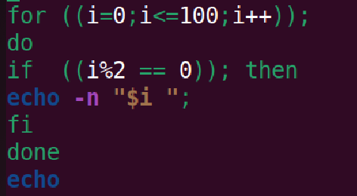

2) Right Angle triangle

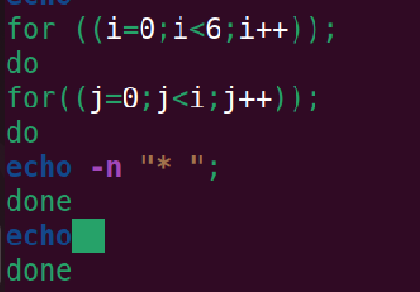

3) Mini ATM

